Secure Bank Pilot Project- Secure Software Engineering

# Secure Coding – Project Cover

Contents

Secure Bank Pilot Project- Secure Software Engineering 1

Secure Coding – Project Cover 1

1. Architecture Diagram 2

1.1. Project Structure: Web Layer - Web Models – Business 2

2. Project Setup 3

3. DB Design 4

4. Login/Logout 4

5. Password - MD5 5

6. Session Invalidate - 5 min (Configurable) 5

7. Fund Transfer 5

8. OTP - Password Reset – Email Generation 6

9. Secure Questions 8

10. Database Models 8

# Architecture Diagram

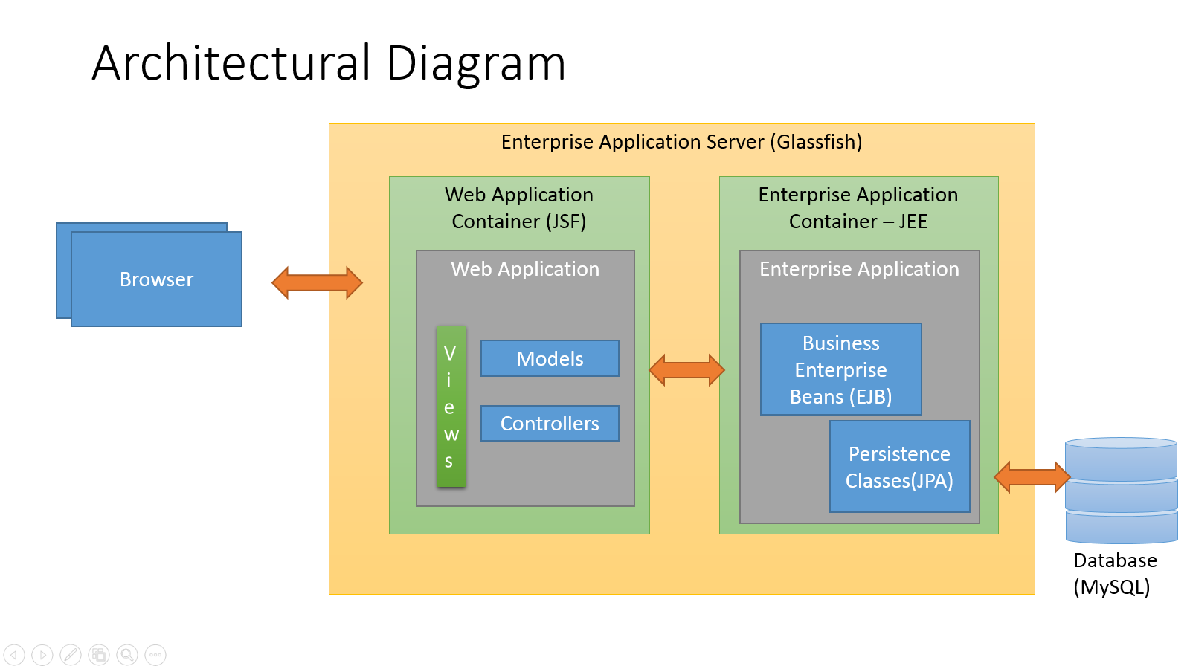

## Project Structure: Web Layer - Web Models – Business

|  |  |
| --- | --- |
| Figure : VIEW LOGIC | Figure :UI MODELS |

|  |  |
| --- | --- |
| Figure : Enterprise Business Beans | Figure : Persistence Layer |

# Project Setup

* 1. Development Environment

Development Editor: NetBeans 8.0

Enterprise Server: Glassfish 4 (Comes along with NetBeans)

JDK: 1.8

Database Design: MySQL Workbench

Database: MySQL

# DB Design

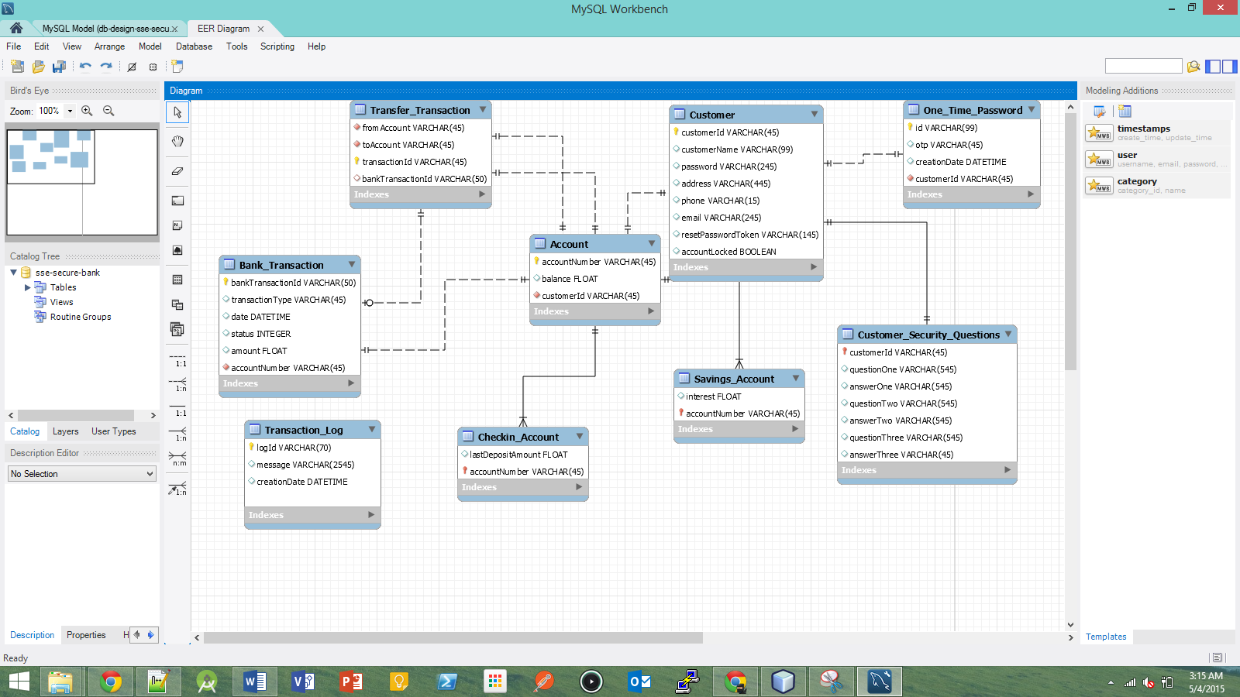

Figure : Database Schema

# Login/Logout

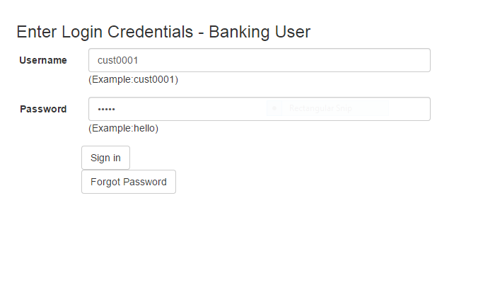

Figure : Account Login Page (LoginPage.xhtml)

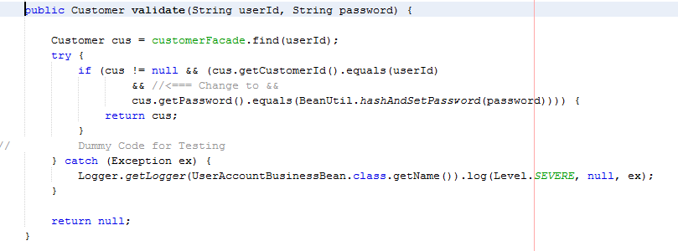

Figure : Validate User Credentials - UserAccountBusinessBean.java

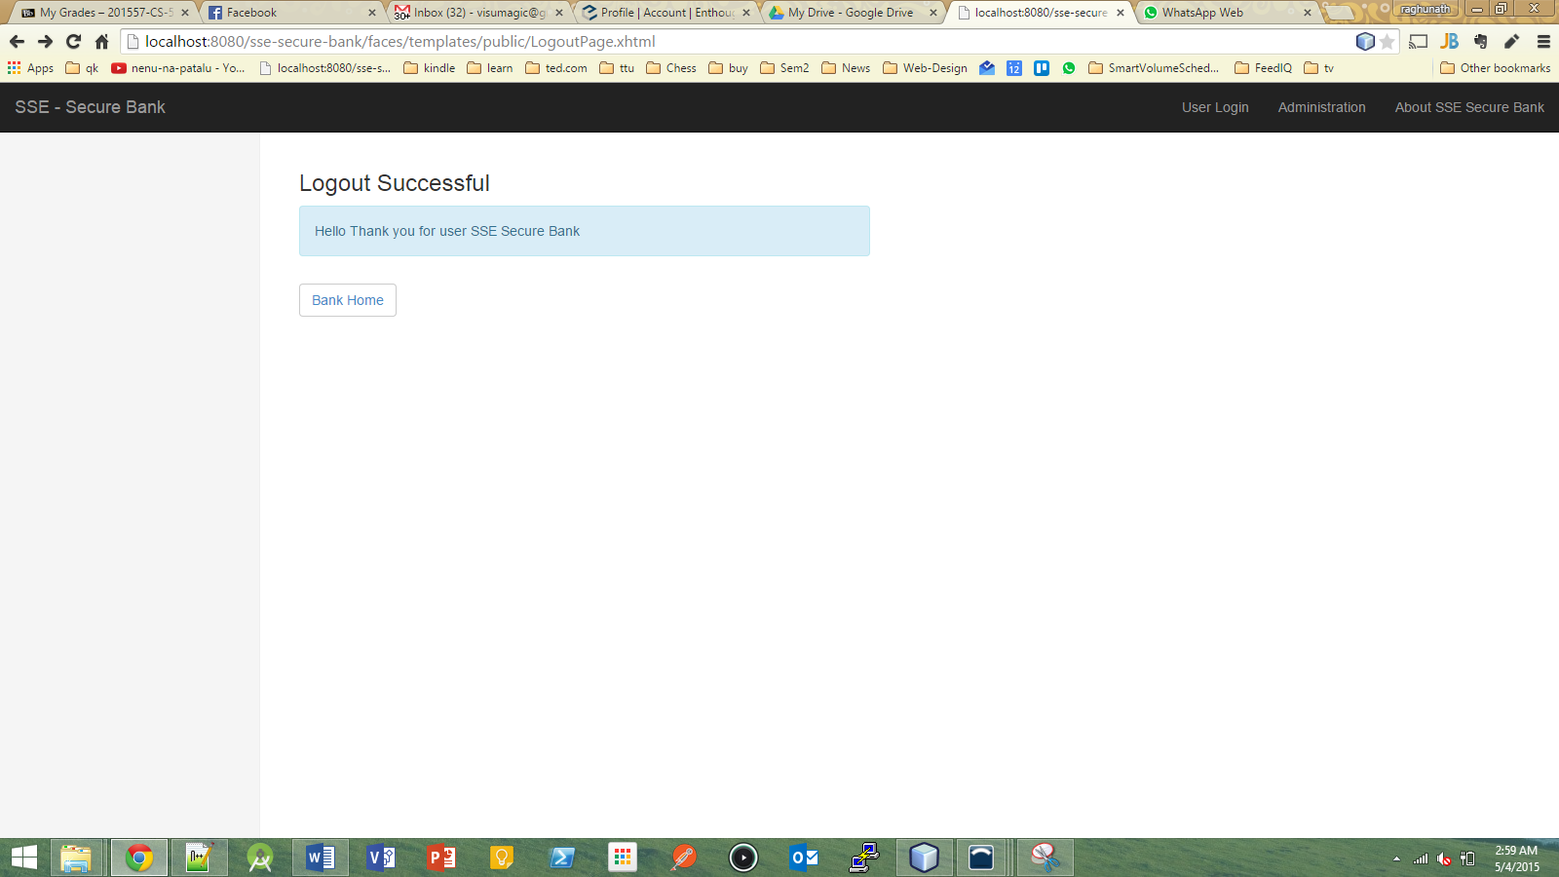

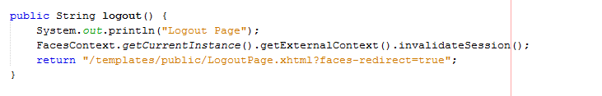

# Password - MD5



Figure : Validate User Credentials - UserAccountBusinessBean.java

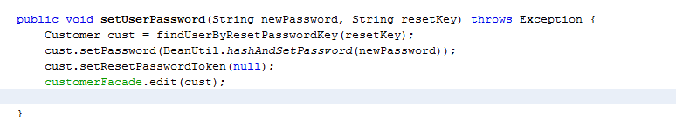

Figure :Set Md5 Password Logic - ResetPasswordUIBean.java

# Session Invalidate - 5 min (Configurable)

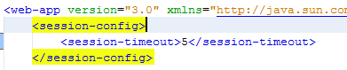

Figure : web.xml

# Fund Transfer

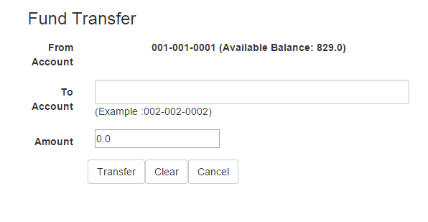

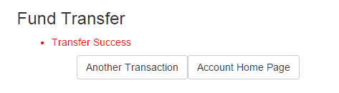

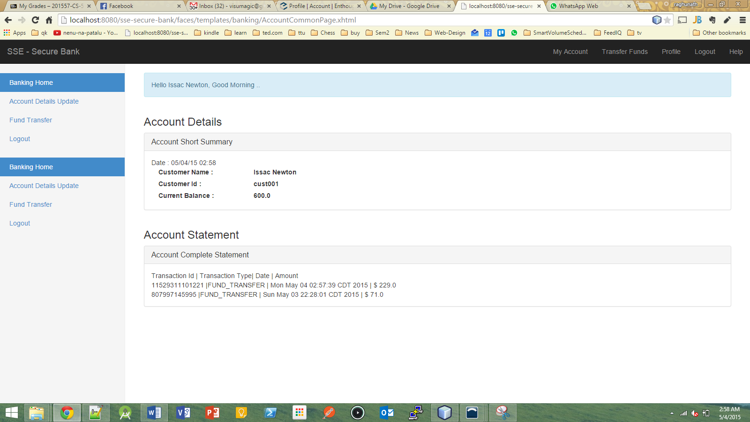

# OTP - Password Reset – Email Generation

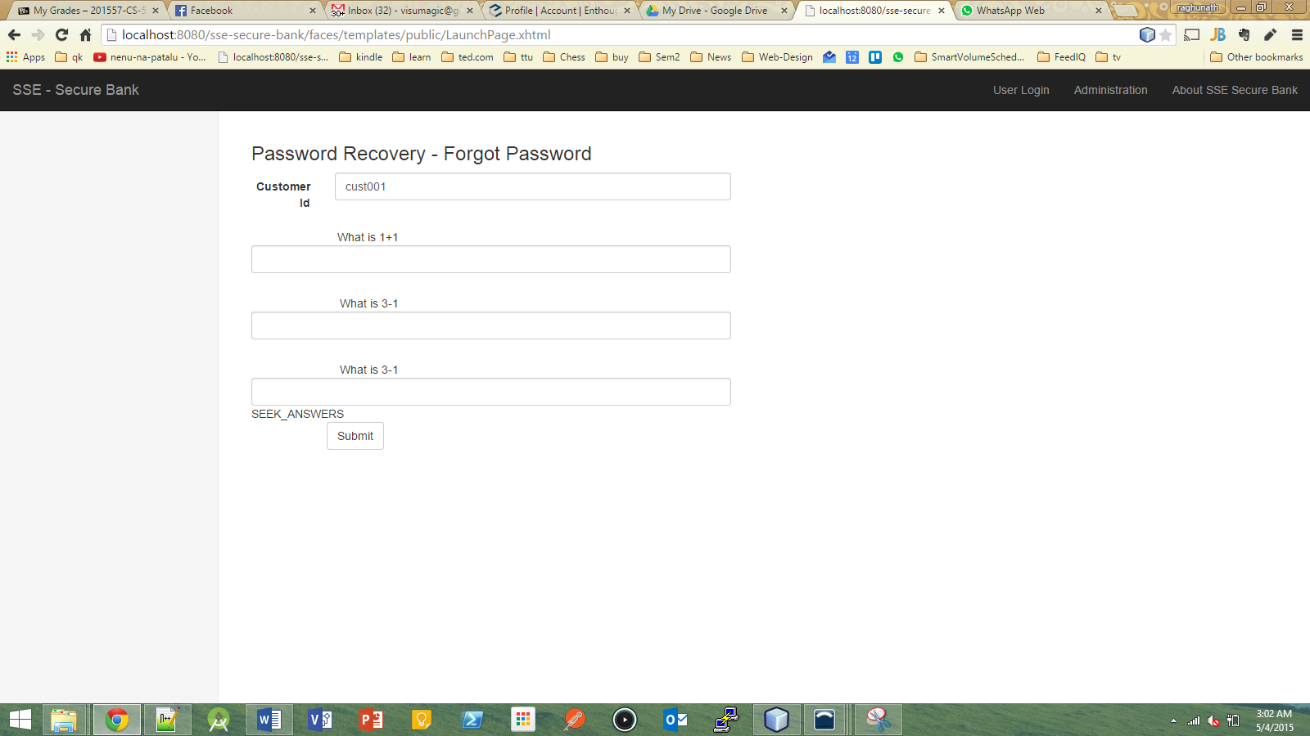

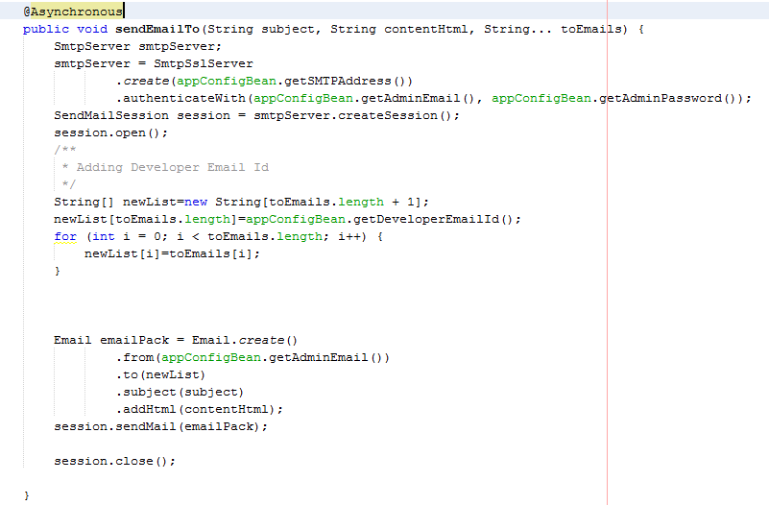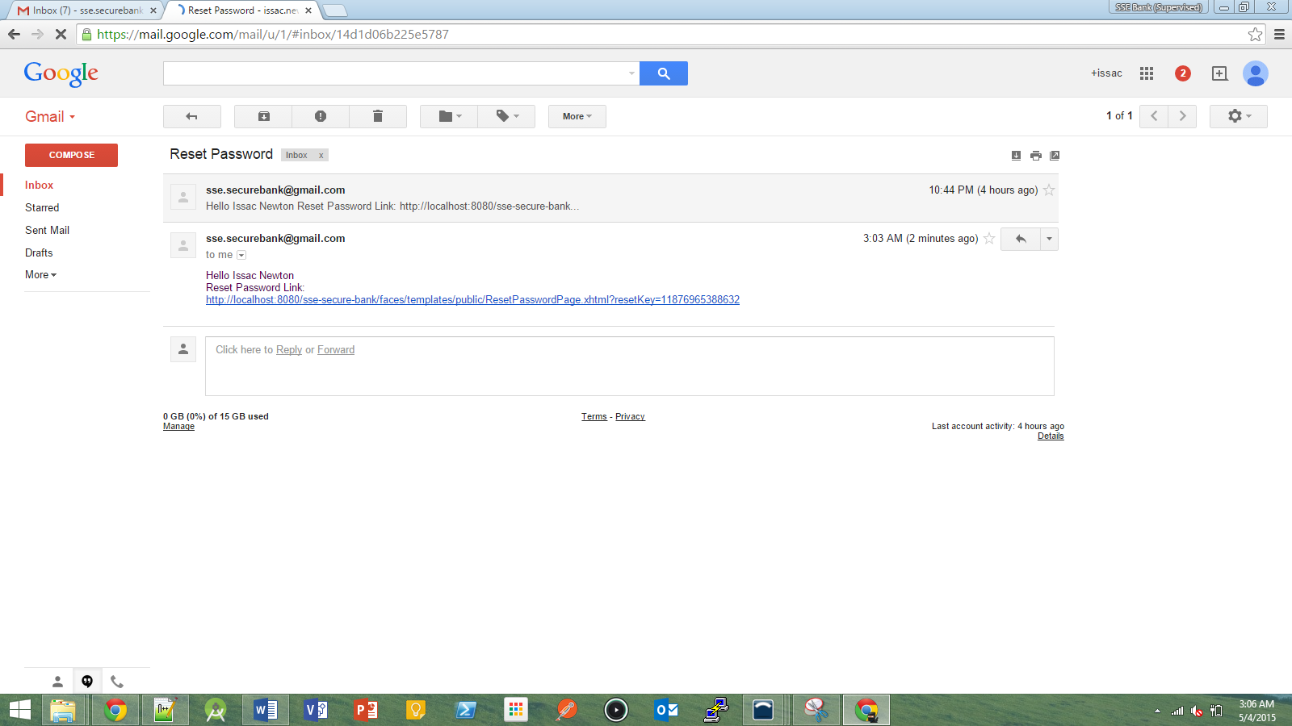

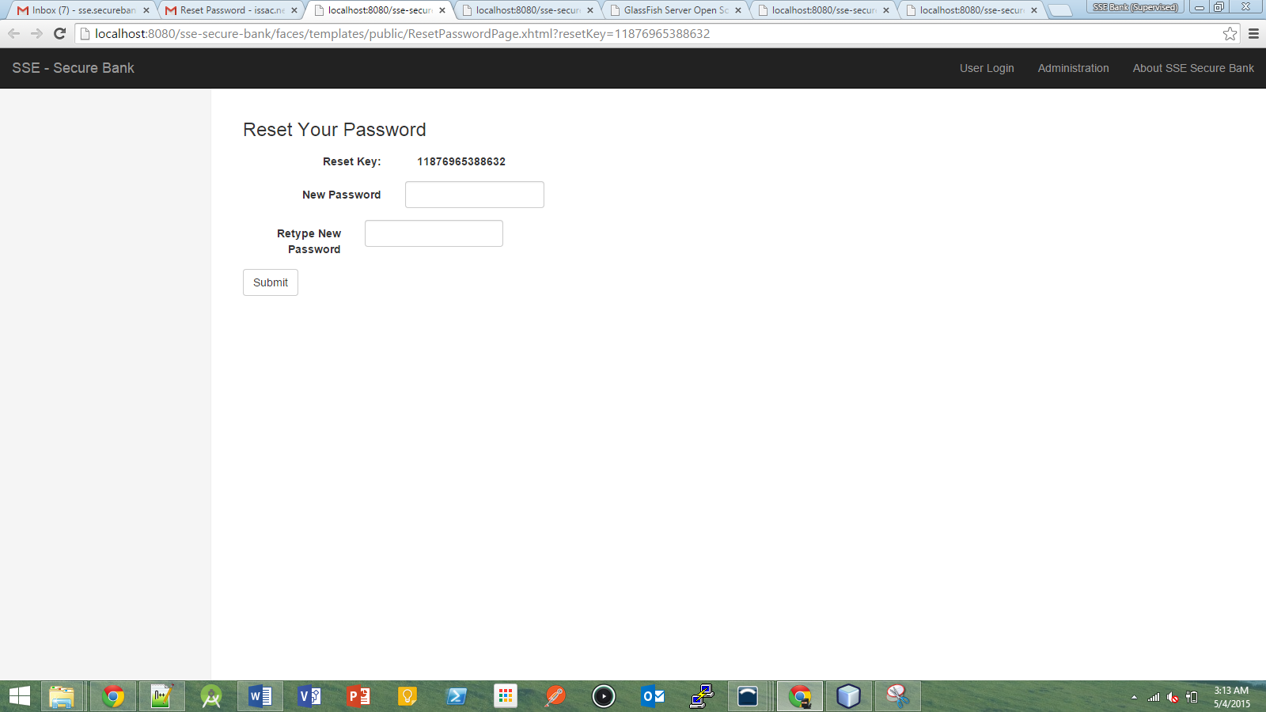

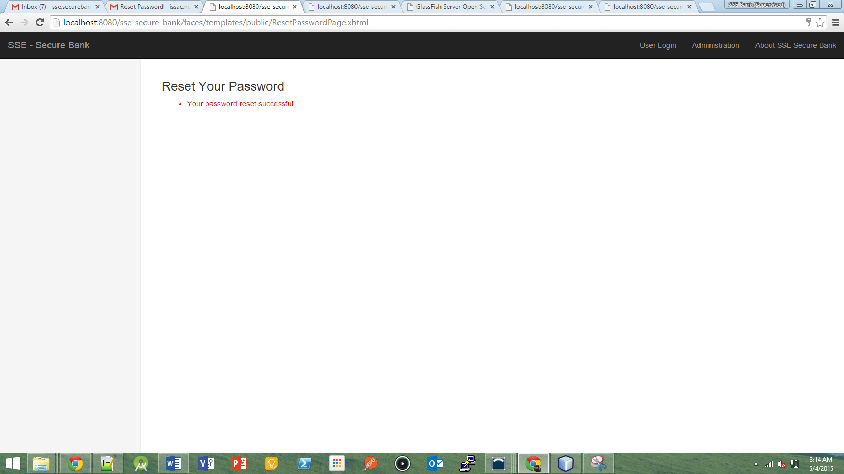

# Secure Questions



# Database Models

